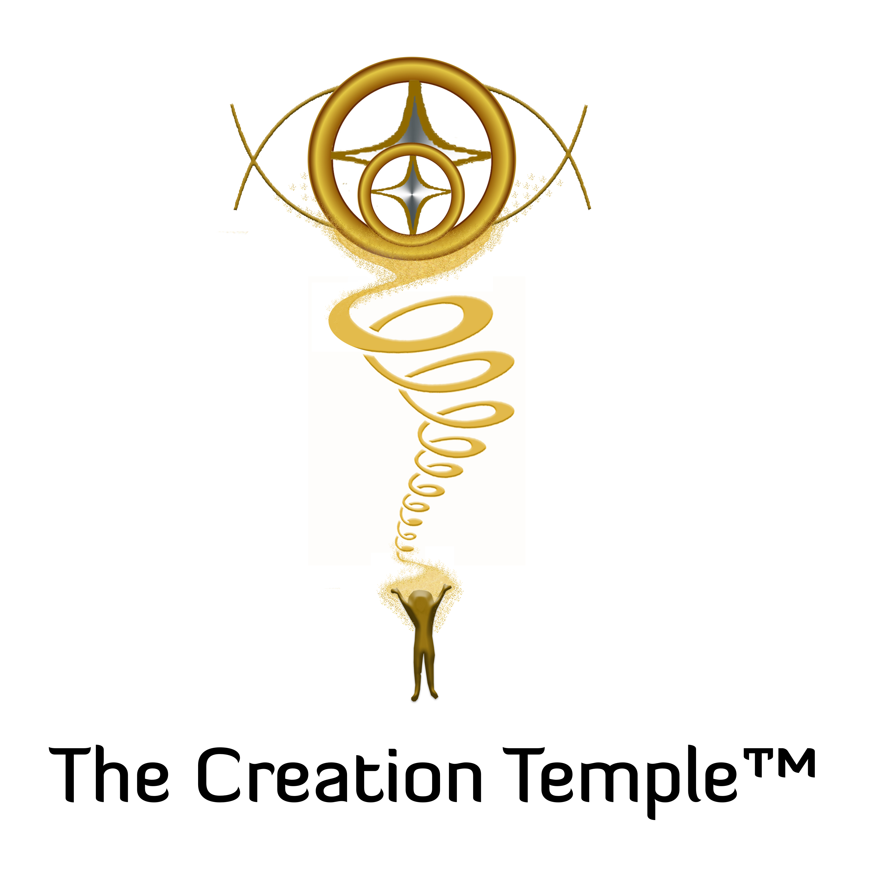
The Creation Temple™
Empowering Creators of Heaven on Earth
The Creation Temple™ is a sacred online space for deeply committed souls to receive grounded guidance and spiritual coaching. In our community we take practical steps forward towards our ascension while honoring and developing our spiritual gifts and the holistic body. As we profoundly nourish our beings, we navigate our rebirthing into our Higher Selves with ease, grace, and wisdom. Focused on similar timelines, we amplify our creations to manifest Heaven on Earth. We are sovereign and in love we travel together.
What you can expect to receive as a Master Creator member:
▪ Nourishing connection with your Soul Family (like-minded and like-hearted individuals) & a strong spiritually grounded community
▪ Practical coaching and support to manifest the creations of your heart for a deeply fulfilling life
▪ Rejuvenation of your body, mind, & spirit so that you can thrive each day with renewed energy and confidence
▪ Grounded suggestions for everyday living on the spiritual path to navigate the sticky situations of life
▪ Leading edge ascension information for an outstanding quality of life
▪ A safe space to heal and remember who you are as a whole, complete being
▪ Increased emotional stability and fortitude to embrace and sail through life’s challenges
▪ Four online Community Connection gatherings each billing cycle (live connection with Susie)
▪ Ceremonies, DNA activations, discussions, and tons of content (video and audio) to assist your journey so that you can finally create the life you know is possible for you
*Master Creators are also in service to the whole. During our gatherings, we send our love to all beings.
Vision Statement
Working with Aleyawah (Gaia’s ascended self), we bring form and substance to our Light Creations of the 5th dimensional reality and beyond. This allows something of form to penetrate the 3-D matrix of planet earth. In this way, our creations emerge into Heaven on Earth. Knowing that everything already exists, we combine our energies to manifest easy and graceful creations in an amplified field.
Join us today in The Creation Temple™ and find comfort in soul family connection as you design your version of Heaven on Earth in your everyday life! {Insert your affiliate link here.}

